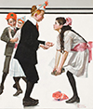
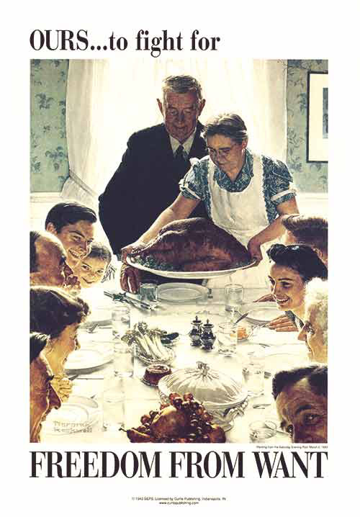
November 28, 2015 – Here we have another year full of memories of family and friends. Today it has been cool (30’s) and rainy. On Thanksgiving Day, when we went to Donnas’ sister for the holiday feasting, Shorts were the order of the day, as it was in the 60’s. Yeah!

Can you believe it, it’s our 13th wedding anniversary tomorrow. I don’t know where the time goes. It has been a whirlwind marriage. So many things go do and see with someone who enjoys the same things as you do. The sharing of tragedy and joy, bring each closer together. The birth of grandchildren and their successes as they grow into adolescence and young adults. The friends and family who support one another through tough times and good times, who never seem to grow old. What joy to have when one can still bask in this gift of a wonderful marriage.

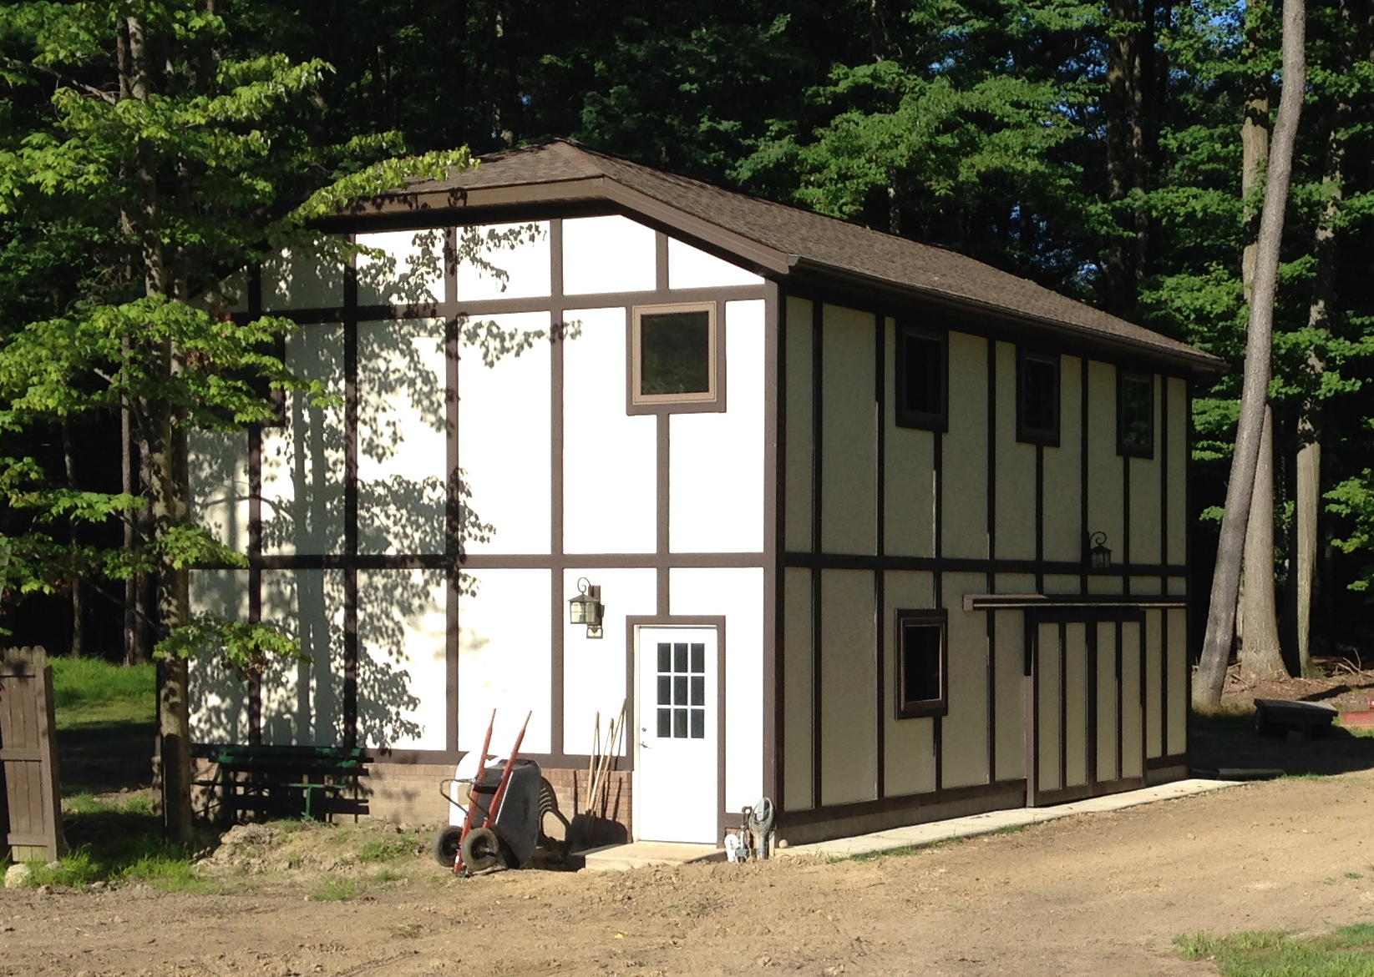
This year was full of projects, which kept us pretty busy. I had a workshop and art studio built in the back yard, in which I did the electrical work, interior painting, and installed the hardwood flooring in the studio (Over 3000 pieces of tongue and groove Hickory). What a job! If you thought my knees looked bad before, I think I wore them out. The construction took from April until August. The Amish did most of the construction. They did an outstanding job. Great fun!

I have completed several wood working projects already and still have a list for more. The studio is complete and I have started to work on a few art projects as well. When Abree, Caleb & Bryson were here in the summer, we built a birdhouse from cedar, which hangs proudly on our fence.

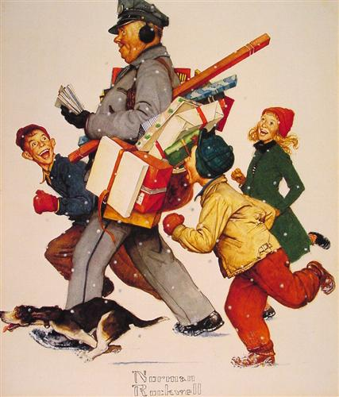
No trips abroad this year with the building and all, but Donna visited the grandkids in Dallas just before the Thanksgiving weekend to get their Christmas Lists for Santa. They are doing great in Dallas. My son Ben, his spouse Robin & kids are doing just fine in the state of Washington. They will be here to visit between Christmas and New Years.

Donna’s office is going through a transition period, as the practice was sold and there are many new electronic files that need to be navigated and learned. She is taking it in stride, where if something needs to be done they just say, “Donna can do it!”

Memories of the past: Today, I happened to be looking at some great Norman Rockwell prints and he had the knack of bringing home what life was all about. He depicted ordinary people doing ordinary things, from waiting in the doctors’ office to sitting at the table for a family feast. Considering the quantity of prints he created, there has got to be at least one, which reminds you of yourself or someone you have known. Kids, family, love, friendship and more, showing what life was like at that time in history. Many of the prints remind me of my childhood when, at Christmas time, we would go to downtown Akron to shop and the window displays at O’neals and Polsky’s were just the cats meow. Just watching the toy trains in the windows were so neat! Life was so much simpler then, when we were young, with no worries or responsibilities and don’t forget Glenn’s Trains where the Lionel trains were sold. It was magic.

I have loaded wood burner and it is nice and warm here in the house. I have a “cool-one” to drink, and there is that last piece of pumpkin pie sitting in the kitchen, if I am very nonchalant, maybe I can sneak in there and make it disappear…hmmmm.

To you, our family, our friends, with our love, respect and admiration, we wish you a wonderful holiday season and a happy, healthy, New Year! So, until next year…we wish you and yours the very best life can offer.
Ben & Donna

